Assignment 2 – Yousef Awad
Section 1: My chosen regulators
I chose the TPS613222ADBVR (5V regulator) and the TPS613221ADBVR (3.3V regulator). I chose this due to the fact that it was quite cheap per unit, as well as the fact that it has a large range of possible input voltages. Alongside this, the same applies for both regulators.

Section 2: 3.3V Regulator
This is the schematic, from WEBench, for the 3.3V regulator:
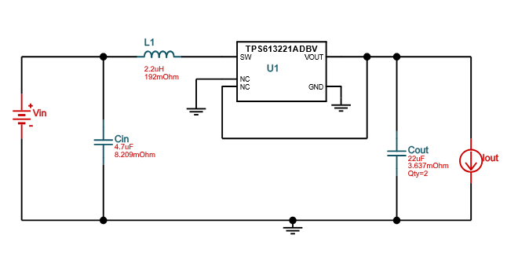

This is the PCB layout from WEBench that I got:
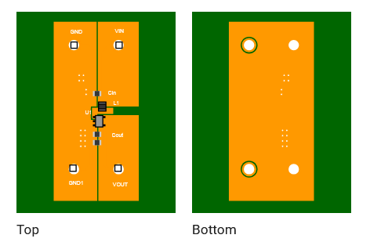
This is the BOM for the Regulator:
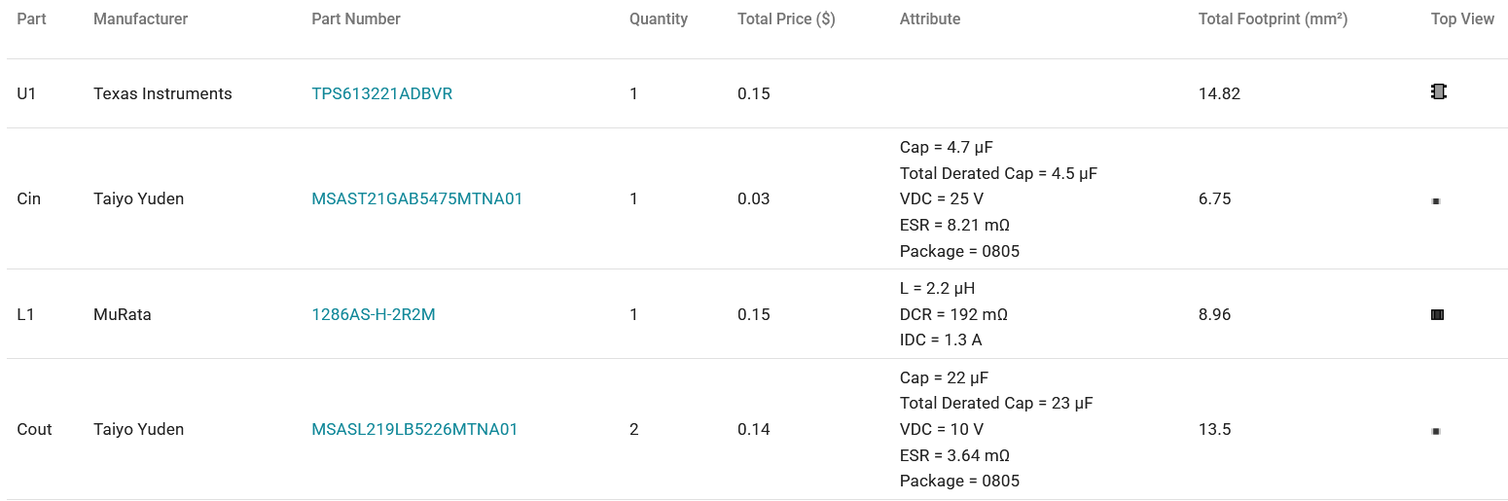
This right here is the Operating Point Table:
Name | Value | Category | Description
Vout | 3.3 V | System Information | Operational Output Voltage
Cin IRMS | 119.78 mA | Capacitor | Input capacitor RMS ripple current
Cin Pd | 117.78 µW | Capacitor | Input capacitor power dissipation
Cout IRMS | 138.81 mA | Capacitor | Output capacitor RMS ripple current
Cout Pd | 35.04 µW | Capacitor | Output capacitor power dissipation
L Ipp | 414.94 mA | Inductor | Peak-to-peak inductor ripple current
Ipp percentage | 176.37% | Inductor | Inductor ripple current percentage (with respect to average inductor current)
L Pd | 11.07 mW | Inductor | Inductor power dissipation
Duty Cycle | 32.30% | System Information | Duty cycle
Efficiency | 87.70% | System Information | Steady state efficiency
Frequency | 815.56 kHz | System Information | Switching frequency
IC Tj | 41.08 °C | IC | IC junction temperature
ICThetaJA | 189.7 °C/W | IC | IC junction-to-ambient thermal resistance
IC Pd | 58.42 mW | IC | IC power dissipation
Pout | 495 mW | System Information | Total output power
Iin Avg | 235.27 mA | IC | Average input current
IC Ipk | 415.59 mA | IC | Peak switch current in IC
Mode | CCM | System Information | Conduction Mode
Vout p-p | 5.19 mV | System Information | Peak-to-peak output ripple voltage
Vin p-p | 14.24 mV | System Information | Peak-to-peak input voltage
Rload_crit | 40 Ω | System Information | Minimum Rload required during Start up
FootPrint | 44 mm² | System Information | Total Foot Print Area of BOM components
Vin | 2.4 V | System Information | Vin operating point
Iout | 150 mA | System Information | Iout operating point
Cin Pd | 117.78 µW | Power | Input capacitor power dissipation
Cout Pd | 35.04 µW | Power | Output capacitor power dissipation
L Pd | 11.07 mW | Power | Inductor power dissipation
IC Pd | 58.42 mW | Power | IC power dissipation
Total BOM | $0.47 | System Information | Total BOM Cost
Total Pd | 69.64 mW | Power | Total Power Dissipation
BOM Count | 5 | System Information | Total Design BOM count

Here is the Log Efficiency Plot versus Current:
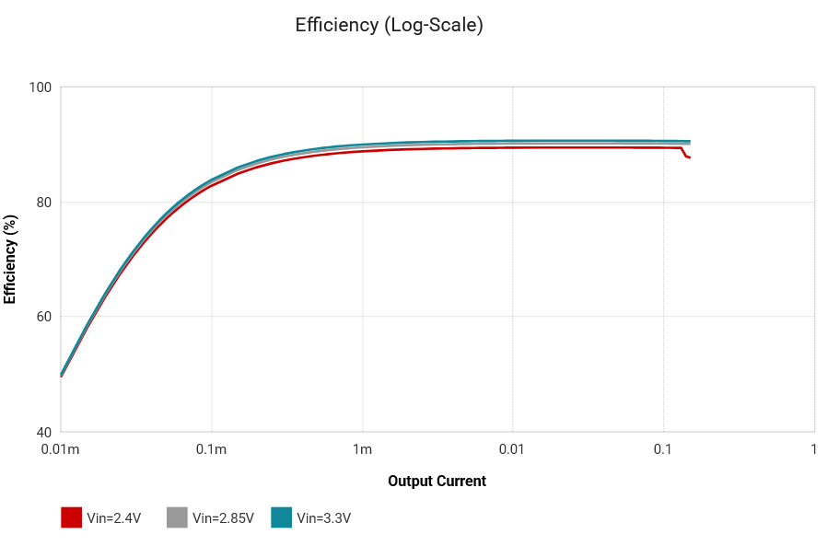
Table 2 (Fully Filled Out):
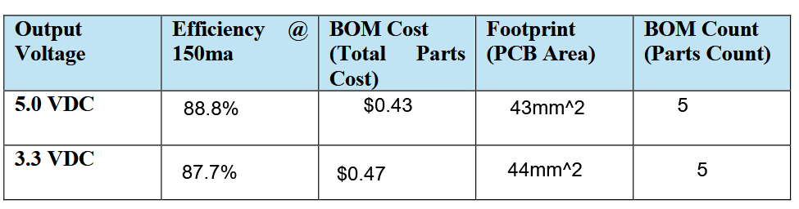

For the following section I will be calculating stuff, so here’s the math:

Now, to compare, my calculations are above, and the actual values on the 3.3V Regulator is the following:

Now, my results are comparable to the ones that are given to me by WEBench, I assume the error on my hand on why it is not perfect is due to my assumptions and rounding that occurred over the course of the mathematics/algebra. Other than that, though, it aligns almost perfectly with the same-ish results.

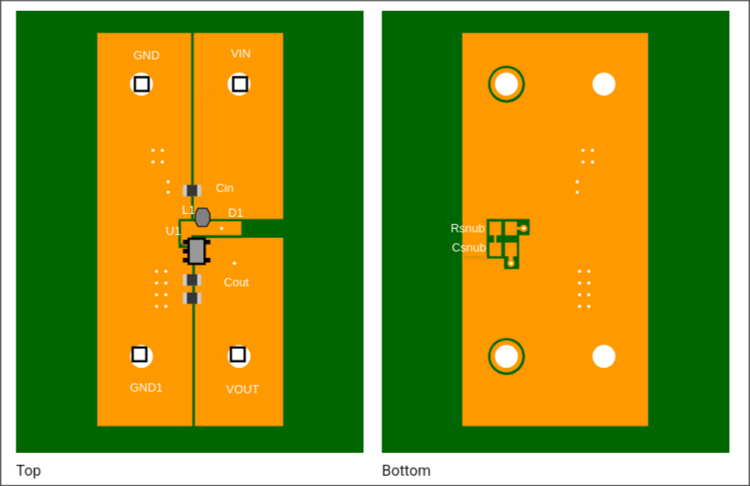
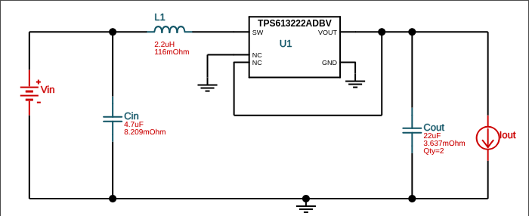
Now, for the maximum junction temperature, from the data sheet, would be 120 degrees Celsius.
Now, with 2 Amps of current, the math is as follows:

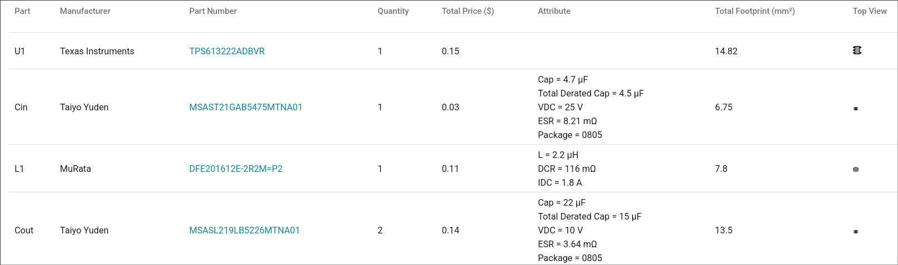
The current limit from the datasheet is between 0.75 and 1.60 Amps, with a typical value of 1.20 Amps.

Section 3: 5V Regulator
Here is the schematic from WeBench for the 5V regulator.

And here is the subsequent pcb layout that WeBench shows me:

Here is the Bill of Materials (BOM) that WeBench shows me:
And here is the subsequent operating point table that it gives me:
Name | Value | Category | Description
Vout | 5 V | System Information | Operational Output Voltage
Cin IRMS | 115.21 mA | Capacitor | Input capacitor RMS ripple current
Cin Pd | 108.95 µW | Capacitor | Input capacitor power dissipation
Cout IRMS | 174.45 mA | Capacitor | Output capacitor RMS ripple current
Cout Pd | 55.34 µW | Capacitor | Output capacitor power dissipation
L Ipp | 399.08 mA | Inductor | Peak-to-peak inductor ripple current
Ipp percentage | 113.44% | Inductor | Inductor ripple current percentage (with respect to average inductor current)
L Pd | 13.07 mW | Inductor | Inductor power dissipation
Duty Cycle | 56.20% | System Information | Duty cycle
Efficiency | 88.8% | System Information | Steady state efficiency
Frequency | 1.43 MHz | System Information | Switching frequency
IC Tj | 45.39 °C | IC | IC junction temperature
ICThetaJA | 189.7 °C/W | IC | IC junction-to-ambient thermal resistance
IC Pd | 81.1 mW | IC | IC power dissipation
Pout | 750 mW | System Information | Total output power
Iin Avg | 351.81 mA | IC | Average input current
IC Ipk | 514.88 mA | IC | Peak switch current in IC
Mode | CCM | System Information | Conduction Mode
Vout p-p | 5.71 mV | System Information | Peak-to-peak output ripple voltage
Vin p-p | 8.02 mV | System Information | Peak-to-peak input voltage
Rload_crit | 500 Ω | System Information | Minimum Rload required during Start up
FootPrint | 43 mm² | System Information | Total Foot Print Area of BOM components
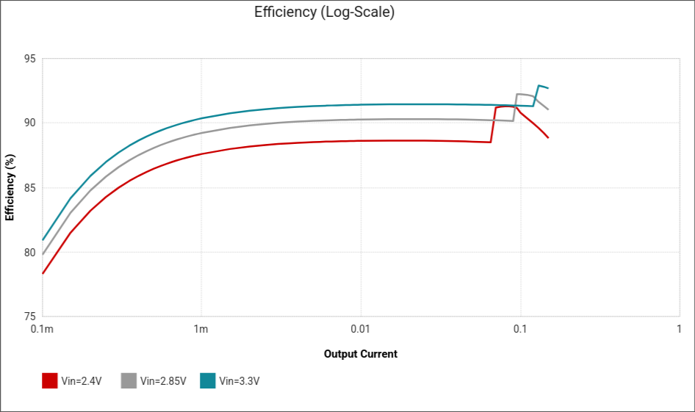  Vin | 2.4 V | System Information | Vin operating point
Iout | 150 mA | System Information | Iout operating point
Cin Pd | 108.95 µW | Power | Input capacitor power dissipation
Cout Pd | 55.34 µW | Power | Output capacitor power dissipation
L Pd | 13.07 mW | Power | Inductor power dissipation
IC Pd | 81.1 mW | Power | IC power dissipation
Total BOM | $0.43 | System Information | Total BOM Cost
Total Pd | 94.35 mW | Power | Total Power Dissipation
BOM Count | 5 | System Information | Total Design BOM count

Here is the respective Log Efficiency plot versus the current:
And here is the table 2 that I filled out previously in section 2 (since it is the same exact data):
For the following section I will be calculating stuff, so here’s the math:

Now, to compare my results with the operating table that was given to me by WeBench, I can see that my results are almost exactly the same as to which the operating table shows! The only difference is that in my Temperature at the Junction value, the Power dissipated was slightly different but did not, thankfully, effect my calculations.
Now, from the data sheet, it showed a maximum junction temperature of 150 degrees centigrade, and 125 degrees centigrade for the recommended maximum.
Given that the current out would be 2 Amps, the junction temperature math would be the following:

Of which, would be a tad too hot compared to the limit of 125 degrees centigrade.

Section 4: Summary
In summary, in this report, I learned of the uses and what is WEBench, as well as how it is used to create designs for DC/DC circuits (and of the fact that it has AC/DC circuits as well). Alongside this, I also learned how to test, simulate, and analyze, the different designs that you can create within WEBench as well as reading the data that it has in it. From that, I learned how the data is used to configure the operating conditions to be to what I expect while also learning of where to find the data sheets to find the experimental maximums.

